**Automated Job Search Agent Process**

Below is the flow for an Automated Job Search Agent process. The flow consists of Login to a job portal and enter a desired job name in the Search box and clicking on the results which gives the number of search results for the desired job.

The flow is achieved by the automation framework “Page Object Model” with TestNG using Selenium with Java.

1. Flow for Driver Initialization, launch browser and URL - ”<https://www.linkedin.com/feed/>”

1. Login to the Job Portal.

1. Flow for Job Search – enter job name in the search box and click enter. It displays all the related search results.

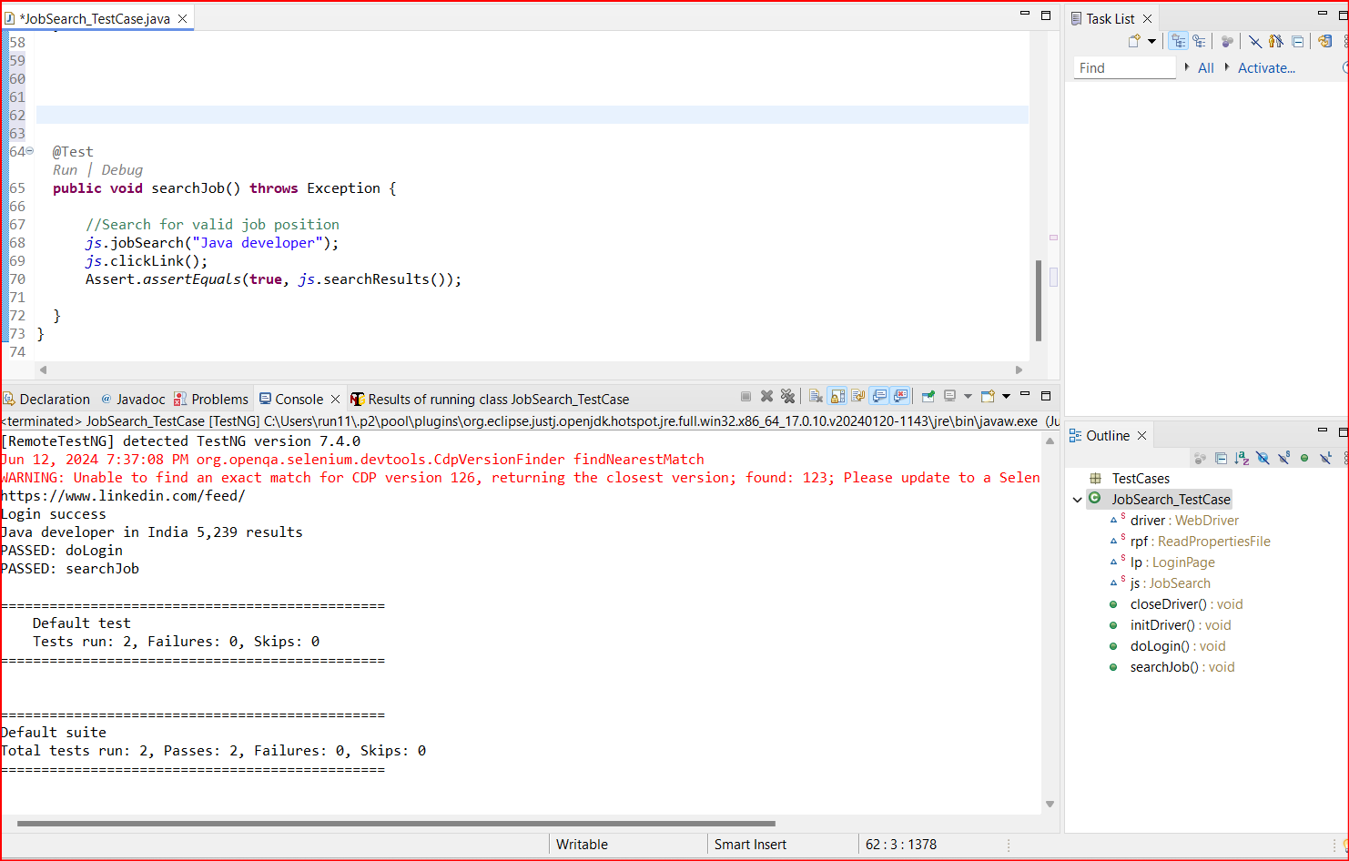

1. Results for the job search “Java developer”.

1. Search results for the entered job search.

1. TestNG Test Results:

Test Results Report:

